Software Requirements Specification

For

Event Management System

Version 0.1

Prepared by

Jugal Kishore Chanda

Student ID: 2017-1-60-134

Email: [jugalchanda7@gmail.com](mailto:jugalchanda7@gmail.com)

|  |  |
| --- | --- |
| Instructor: | MD. Mohsin Uddin |
| Course: | Software Engineering |
| Class Section: | 3 |
| Date: | 12-04-2020 |

**Contents**

|  |  |  |  |
| --- | --- | --- | --- |
| **1** | **Introduction** | **……………………………..** | 3 |
|  | 1.1. Purpose | **……………………………..** | 3 |
|  | 1.2. Product Scope | **……………………………..** | 3 |
| **2** | **Overall Description** | **……………………………..** | 3 |
|  | 2.1 Product Perspective | **……………………………..** | 3 |
|  | 2.2 Product Functions | **……………………………..** | 3 |
|  | 2.3 User Classes and Characteristics | **……………………………..** | 4 |
|  | 2.4 Operating Environment | **……………………………..** | 4 |
| 3 | **External Interface Requirements** | **……………………………..** | 5 |
|  | 3.1 User Interfaces | **……………………………..** | 5 |
|  | 3.2 Hardware Interfaces | **……………………………..** | 19 |
|  | 3.3 Software Interfaces | **……………………………..** | 19 |
|  | 3.4 Communications Interface | **……………………………..** | 19 |
|  | **Appendix B: Analysis Models** | **……………………………..** | 20 |
|  | Use Case Diagram | **……………………………..** | 20 |
|  | Class Diagram | **……………………………..** | 21 |
|  | Sequence Diagram | **……………………………..** | 22 |
|  | Activity Diagram | **……………………………..** | 23 |

**1. Introduction**

1.1 Purpose

The main purpose of this project is to create a platform where university students can find all events of their university and know the updated news and notices from one place and the organizer of the events can manage the student’s information who were participating in their past events.

1.2 Product Scope

This product is designed for university or any kind of educational institute where their clubs arrange many educational events many times.

**2. Overall Description**

2.1 Product Perspective

The perspective of this product is to create a platform where students can easily find themselves interested events which are arranged by many clubs of their university and find updated news and notices published by their university.

2.2 Product Functions

Functional Requirements:

|  |  |
| --- | --- |
|  | The system have five kinds of user.   * Students * Clubs * Main admin |
|  | The clubs can open an event in this system and manage the event through this system properly by following this way   * They can create an event in this platform. * They can take register of students who are interested to participate this event * They can send SMS or mail to the students by using this system. * They can manage all of student information by this system and they can download student information from this system * They can make certificate for the students through this system. For this we give some template of certificate. They need to use one of them for make certificate. They also print this certificate if this device where the system is running is connected to a printer. |
|  | Students can see all of the events and can also see the details of this event and they can register them for participating a particular event. |
|  | The main admin is university authority. They can create a club, add an executive member of a club, remove an executive from a club and update news and notices and academic calendar of the university. |

Nonfunctional Requirements:

|  |  |
| --- | --- |
|  | The system have strong security. |
|  | The system manage all the student information securely and must verify the students who have come from a university who are from a particular university |
|  | The system manage the payment issues perfectly. |
|  | The system be user friendly. |

2.3 User Classes and Characteristics

There are three Character of use:

1. University Students
2. University Club
3. University Authority

2.4 Operating Environment

For accessing this system user need a modern browser of a PC, tab or mobile phone with any operating system.

**3. External Interface Requirements**

3.1 User Interfaces

0) Students can register on this platform by giving the following information. This is required for those students who are willing to be an executive member of any club. It is not necessary for general user.

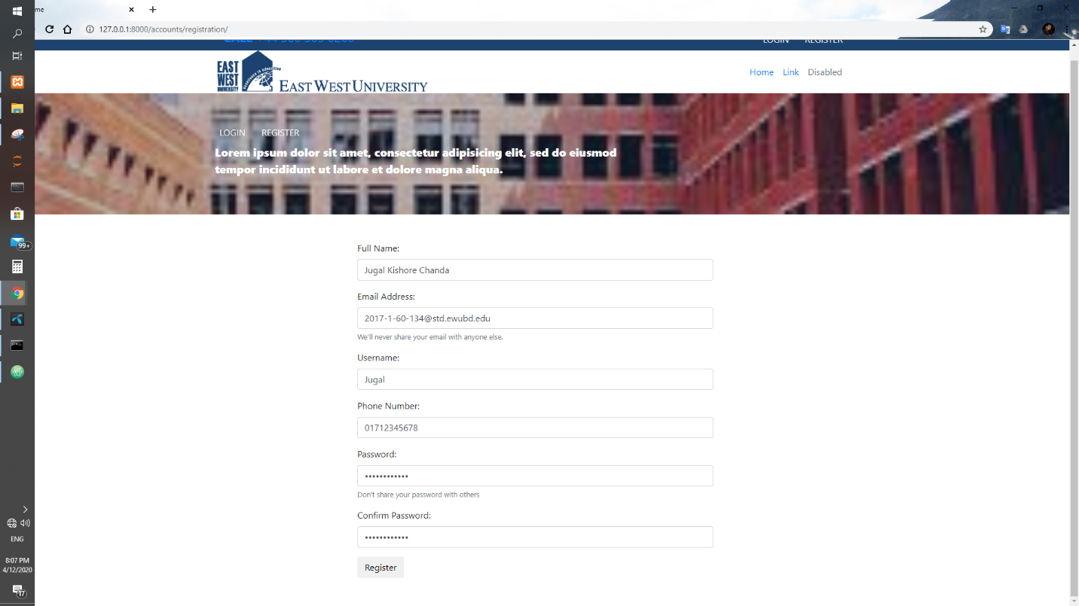

1) Login Admin Panel:

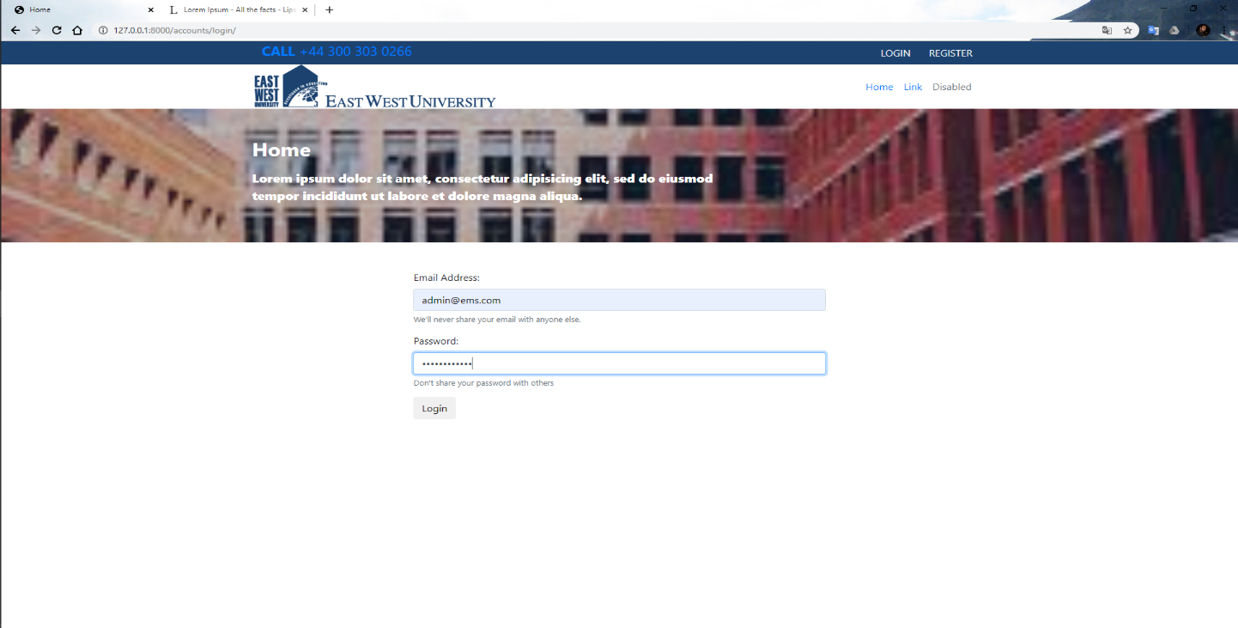

2) Admin Dashboard

This dashboard is accessed by university authorities.

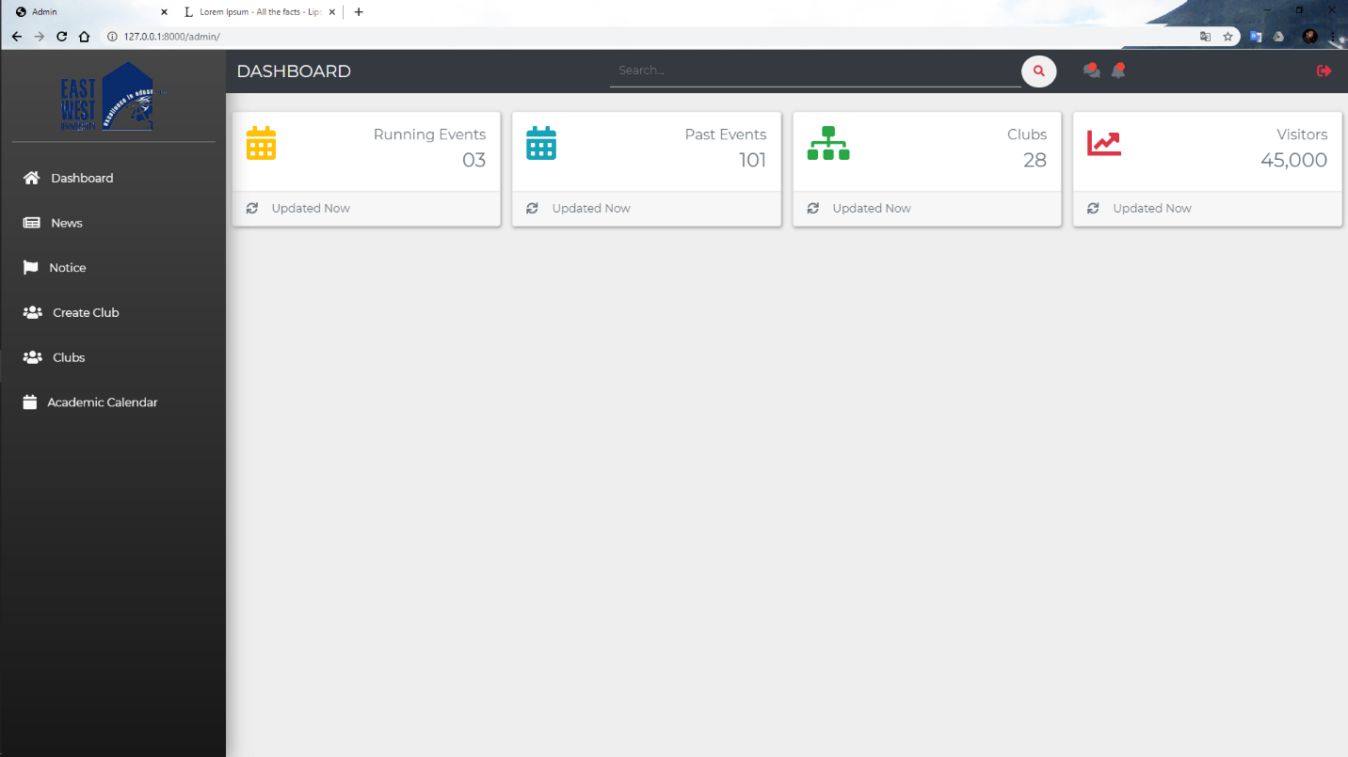

3) University authority can add recent news.

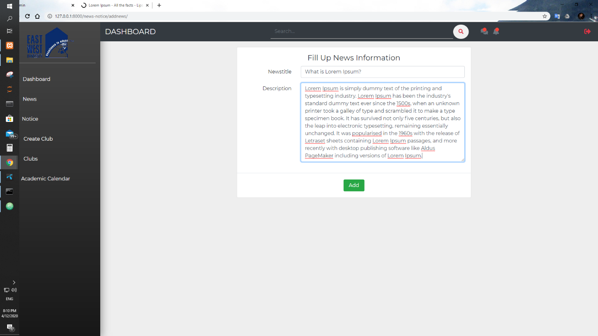

4) University authority can add a recent notice

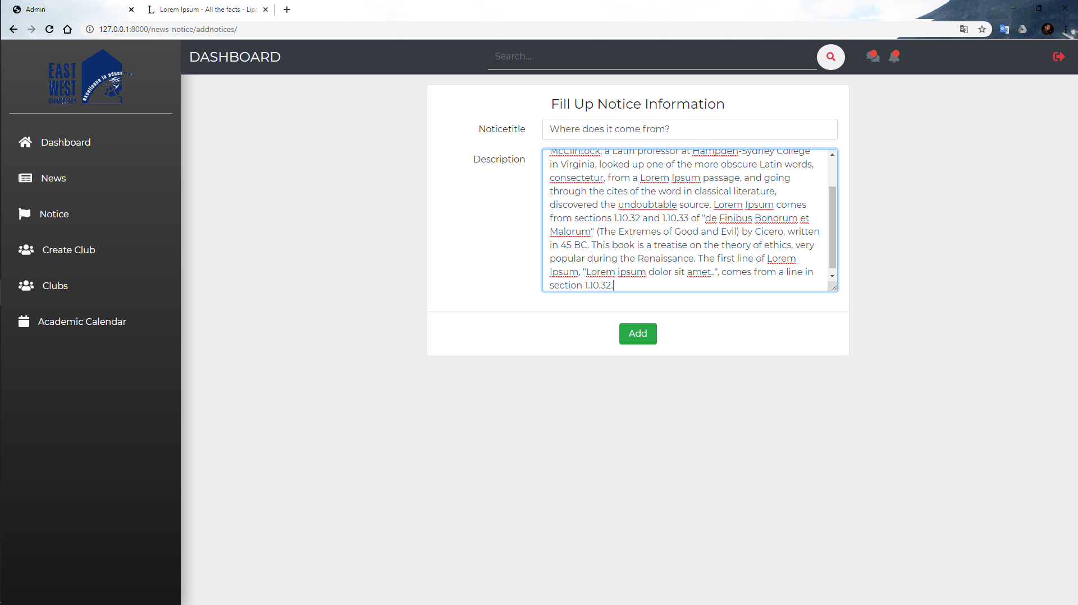

5) University authority can see all added news and can delete unnecessary news

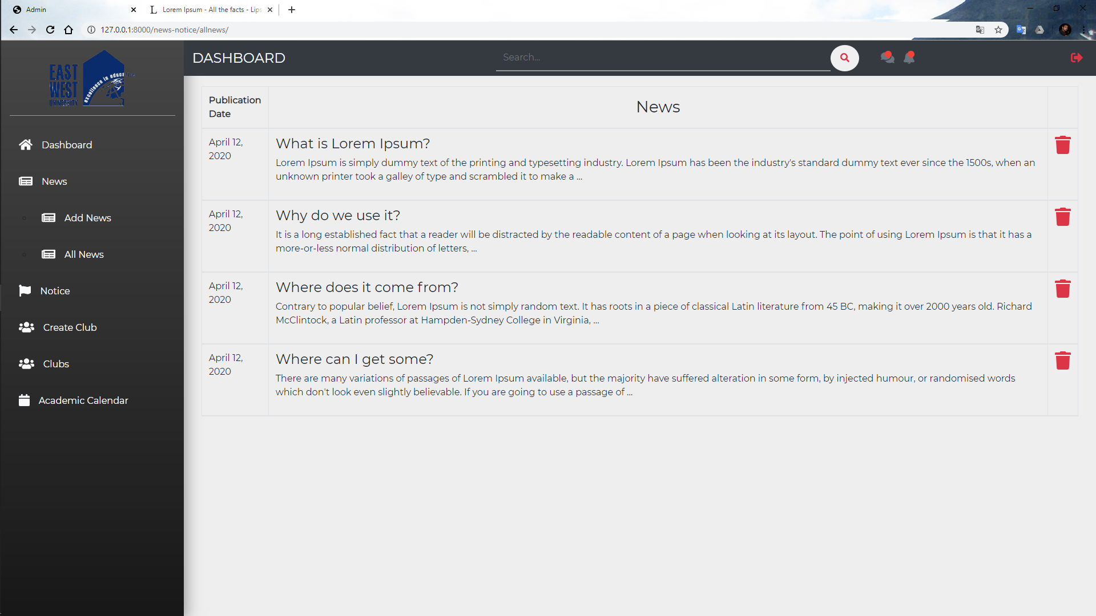

6) University authority can see all added notice and can delete old notice

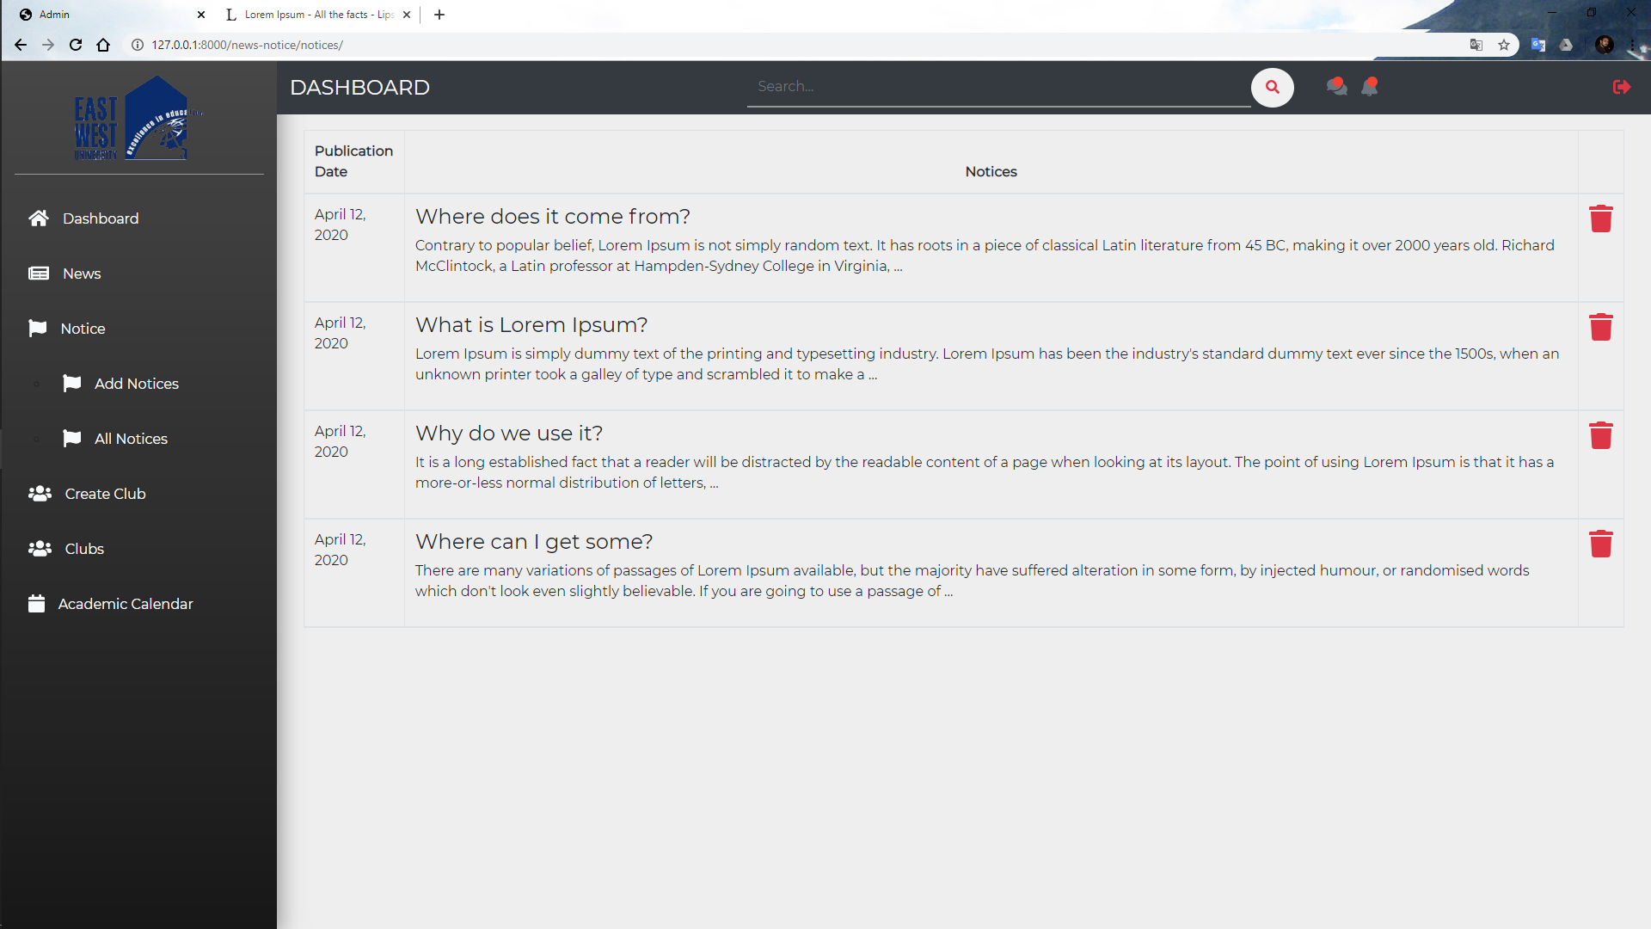

7) University authority can add a new club

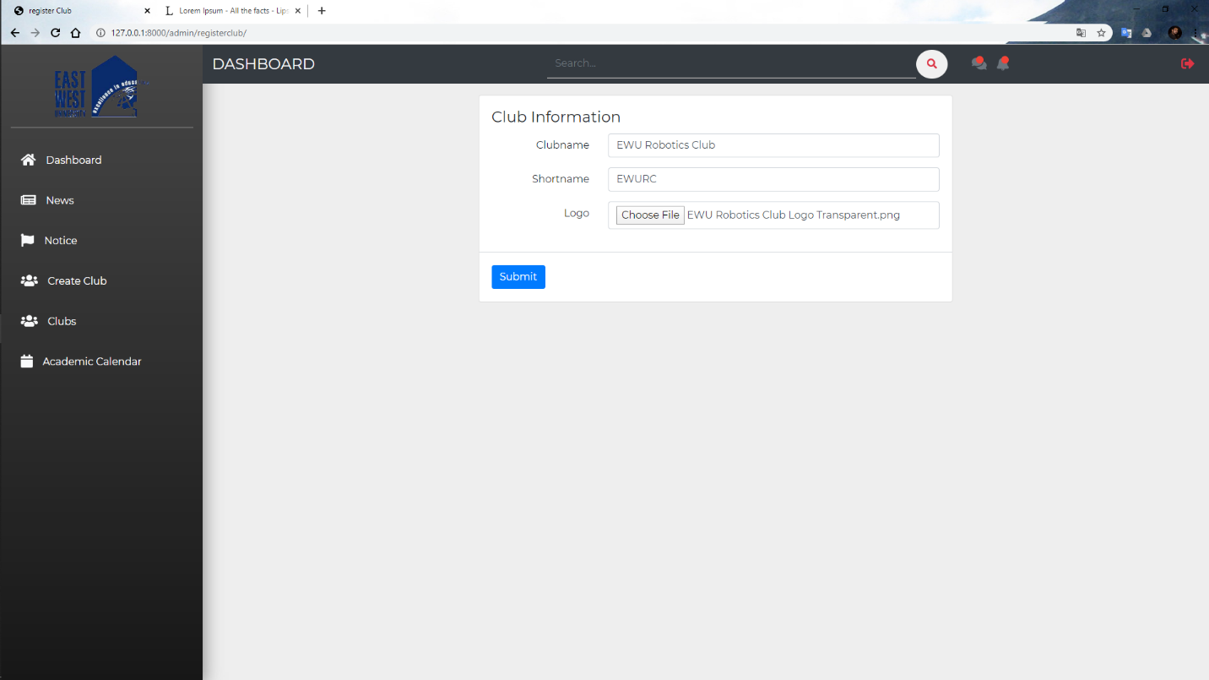

8) University authority can see all clubs in university. Authority can temporary disable club.

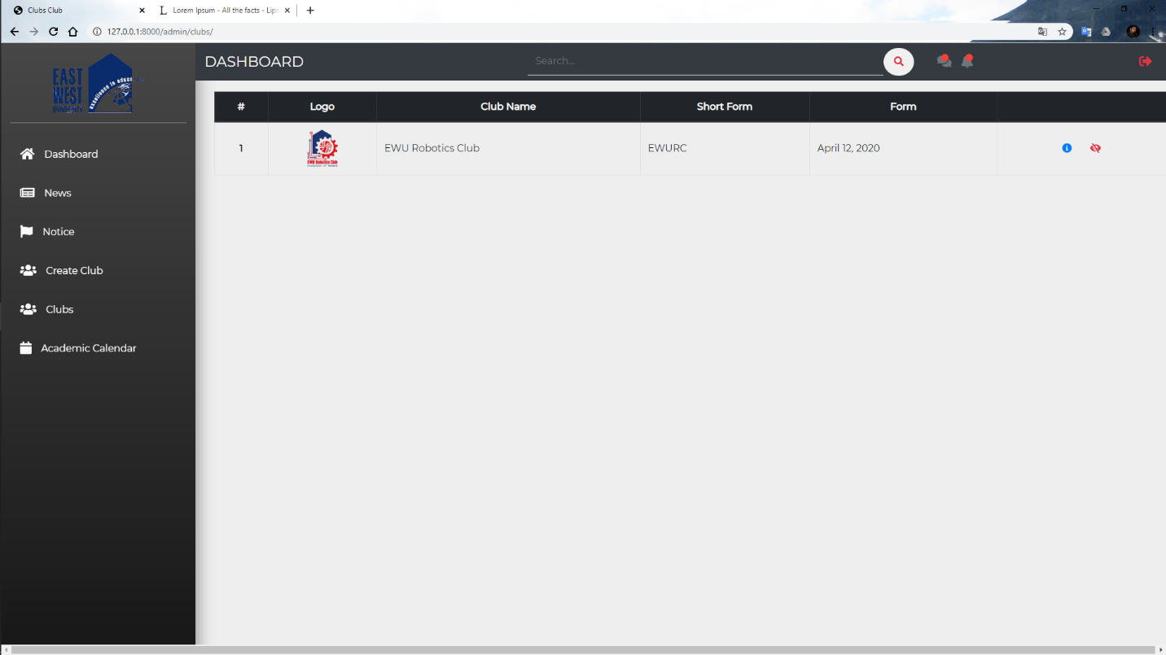

9) University authority can add an executive member of every club.

Search by email address for adding an executive member.

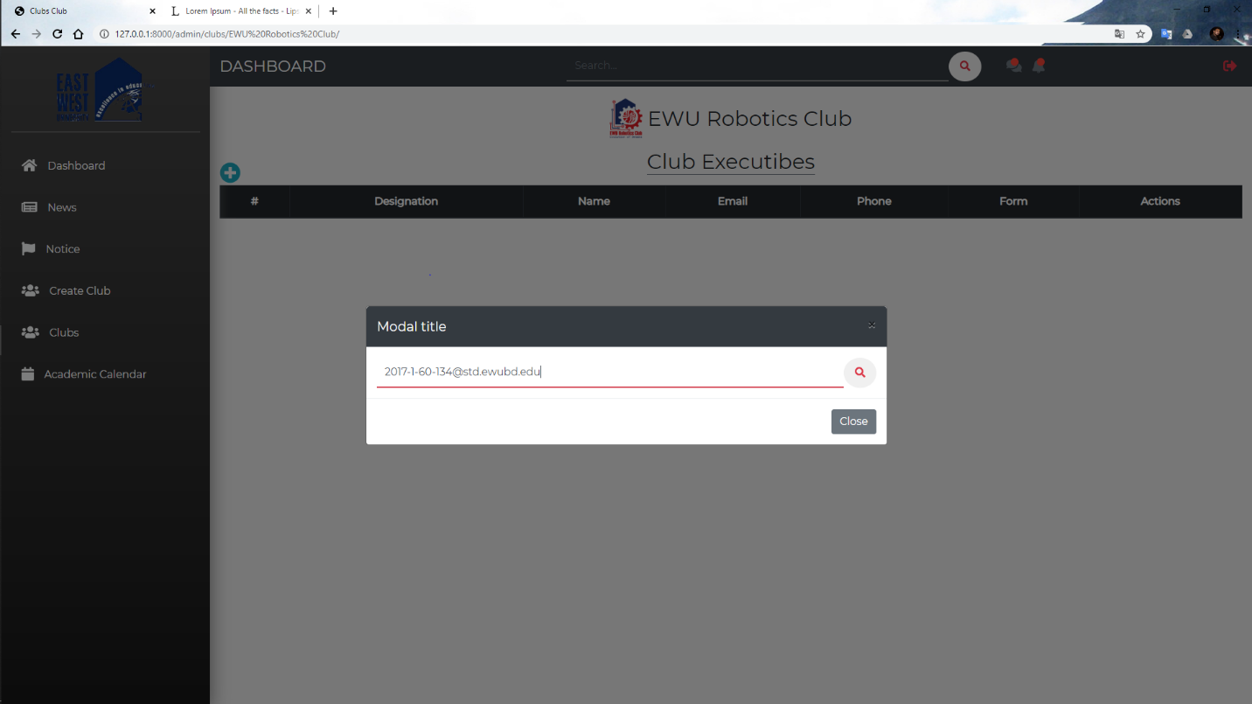

If the email is valid for if this user has ability to be an executive member authority can add him.

The ability is checked by the following information.

1. Is he an executive member of another club?.
2. Is he an admin?

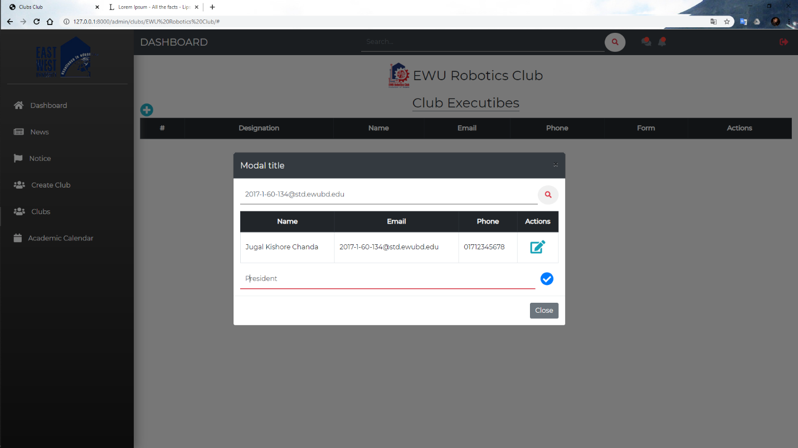

10) Authority can change executive by deleting this executive and add new executive. 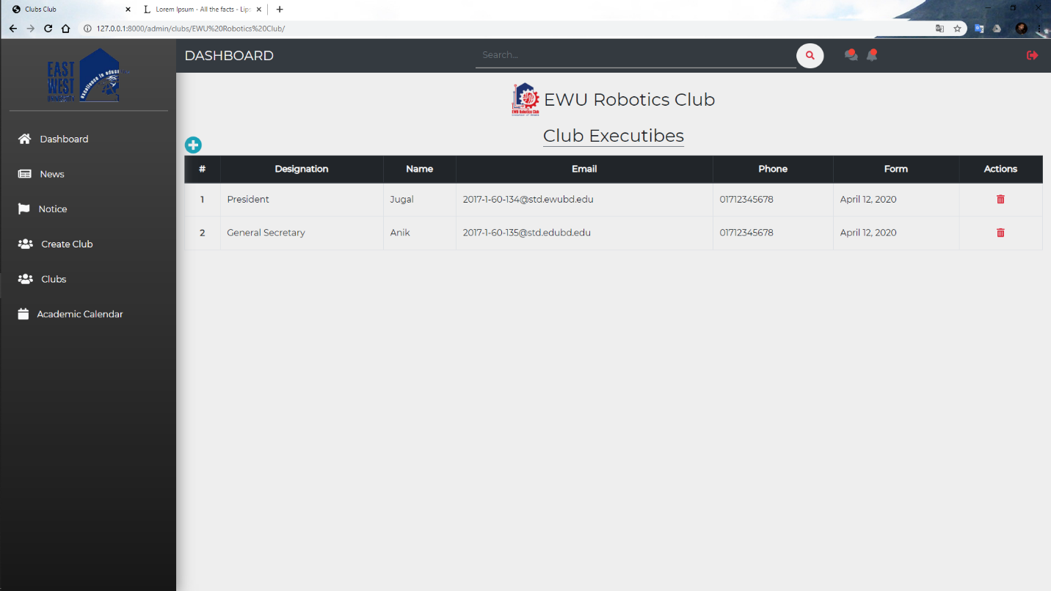

11) the Authority can add academic calendar.

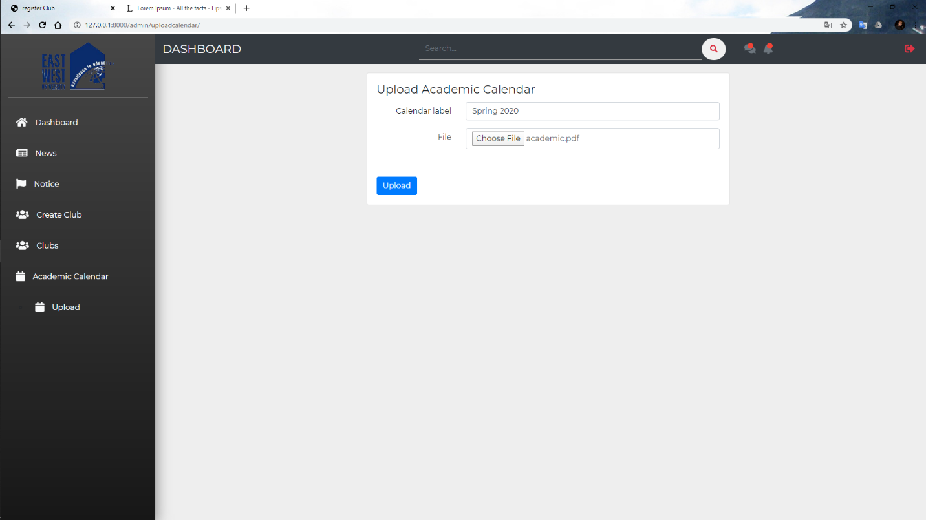

Now let’s see how to club creates an event.

12) At the first student login this platform. If he is an executive member of any club and this club is active then he can see club dashboard

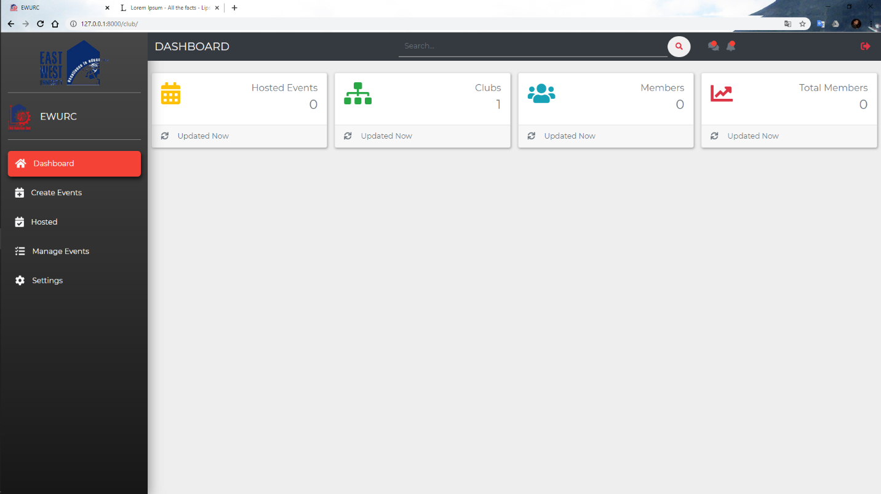

13) Executive can create an event for their club by giving the following information.

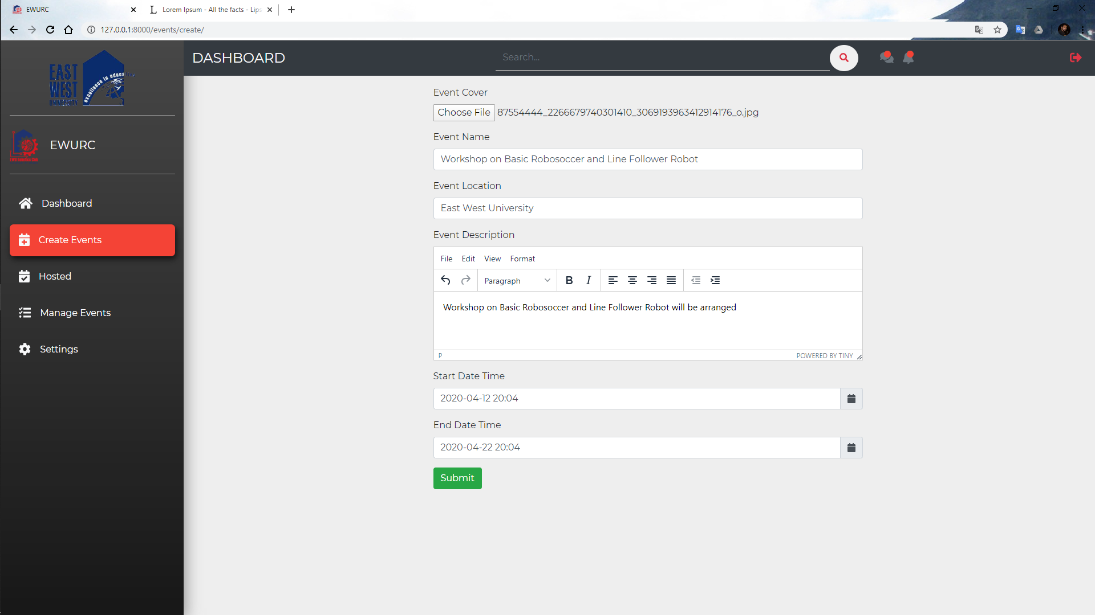

14) Executive can see all previous events hosted by this club

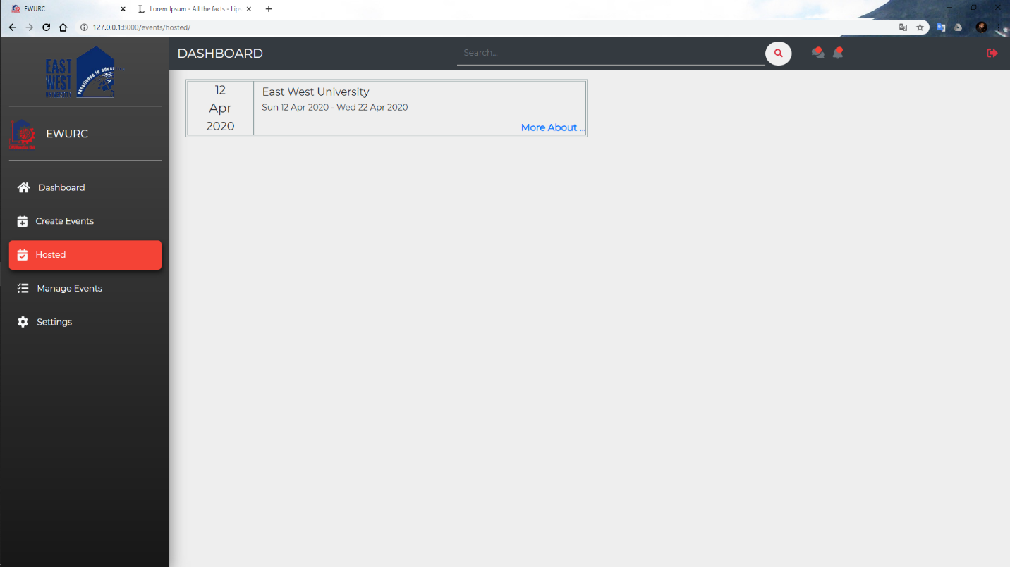

15) And see event information

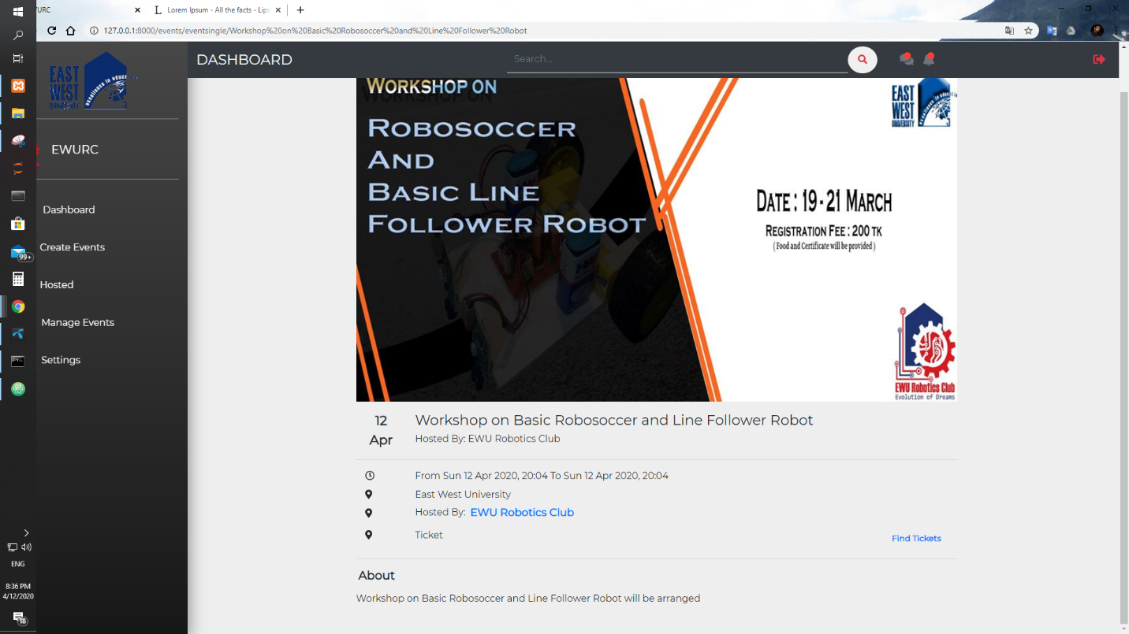

Now it’s time to see how users can register this event.

16) General user view of this platform

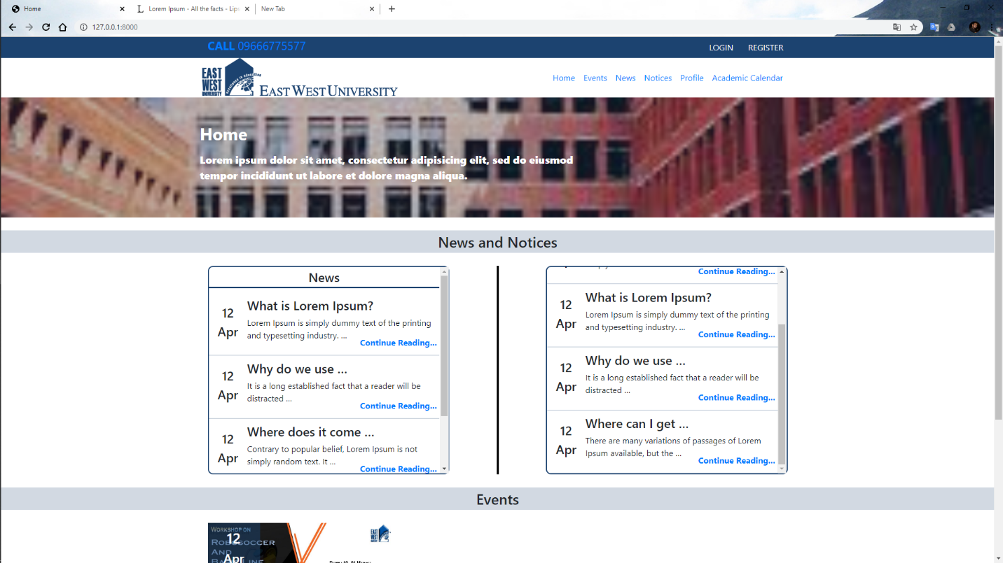

17) Go to evens and see all events and

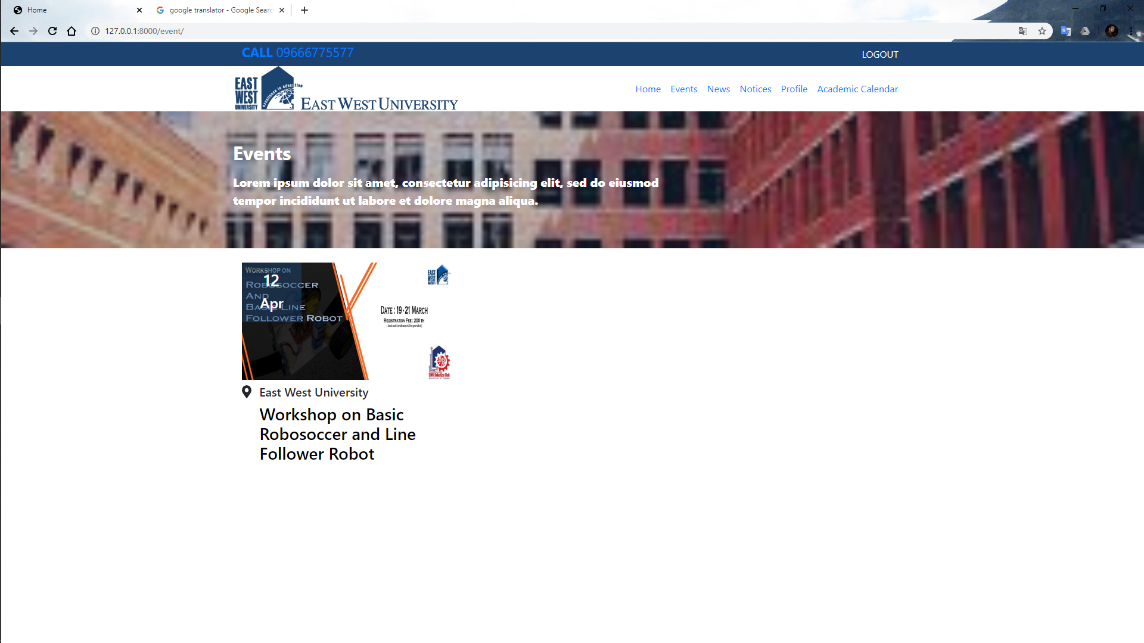

18) After choosing one event user can see this

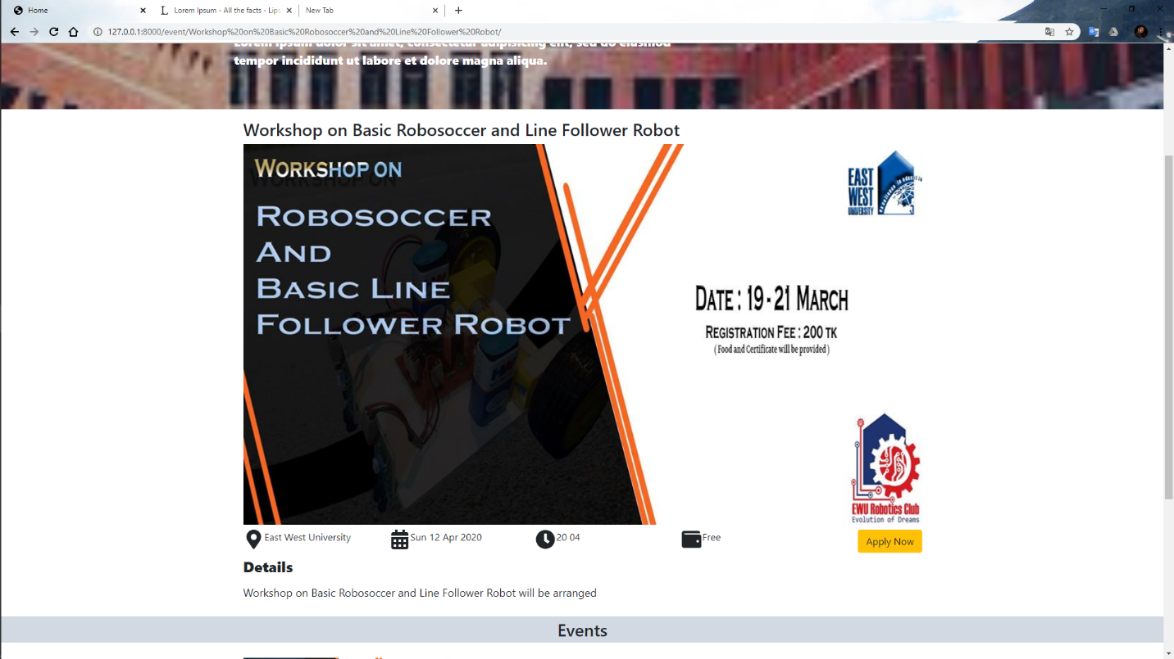

19) Clicking apply now button and user registration form. After filling up this user can register in the particular event.

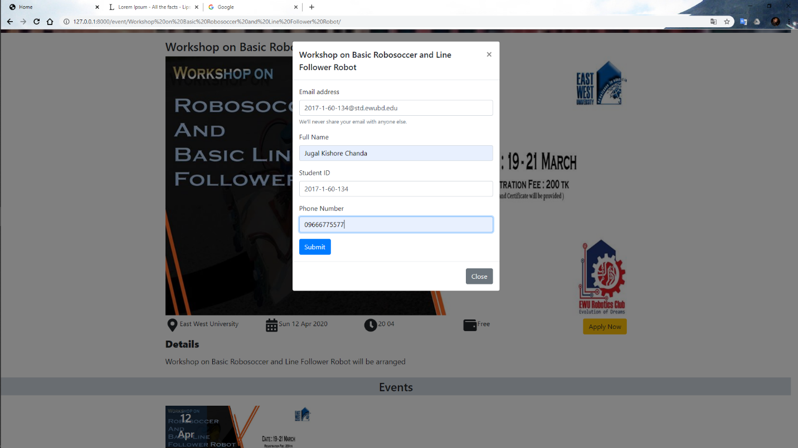

Now again go to club view.

20) Executive can see who register for this event and their information are

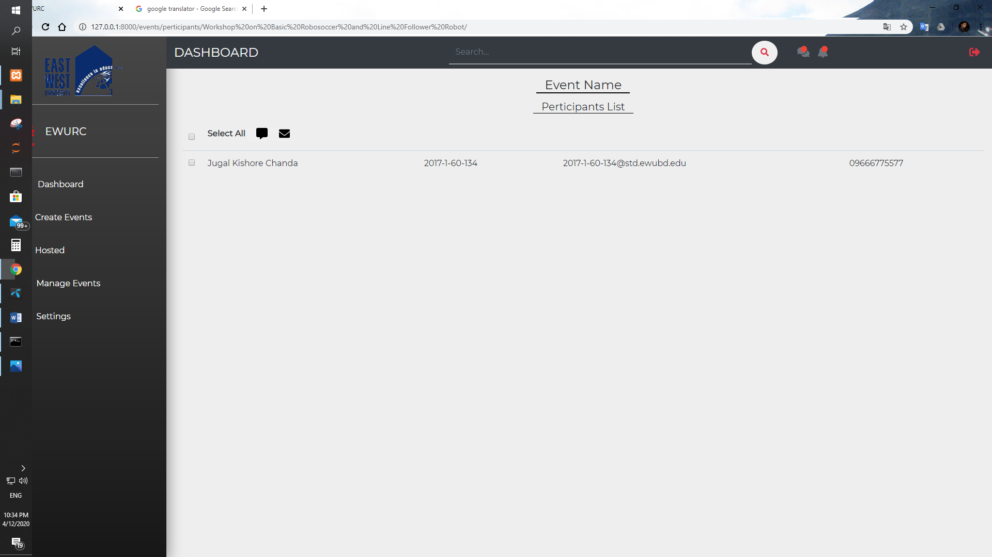

21) Executive can send email by following formats.

To select participants who are allowed to receive this email.

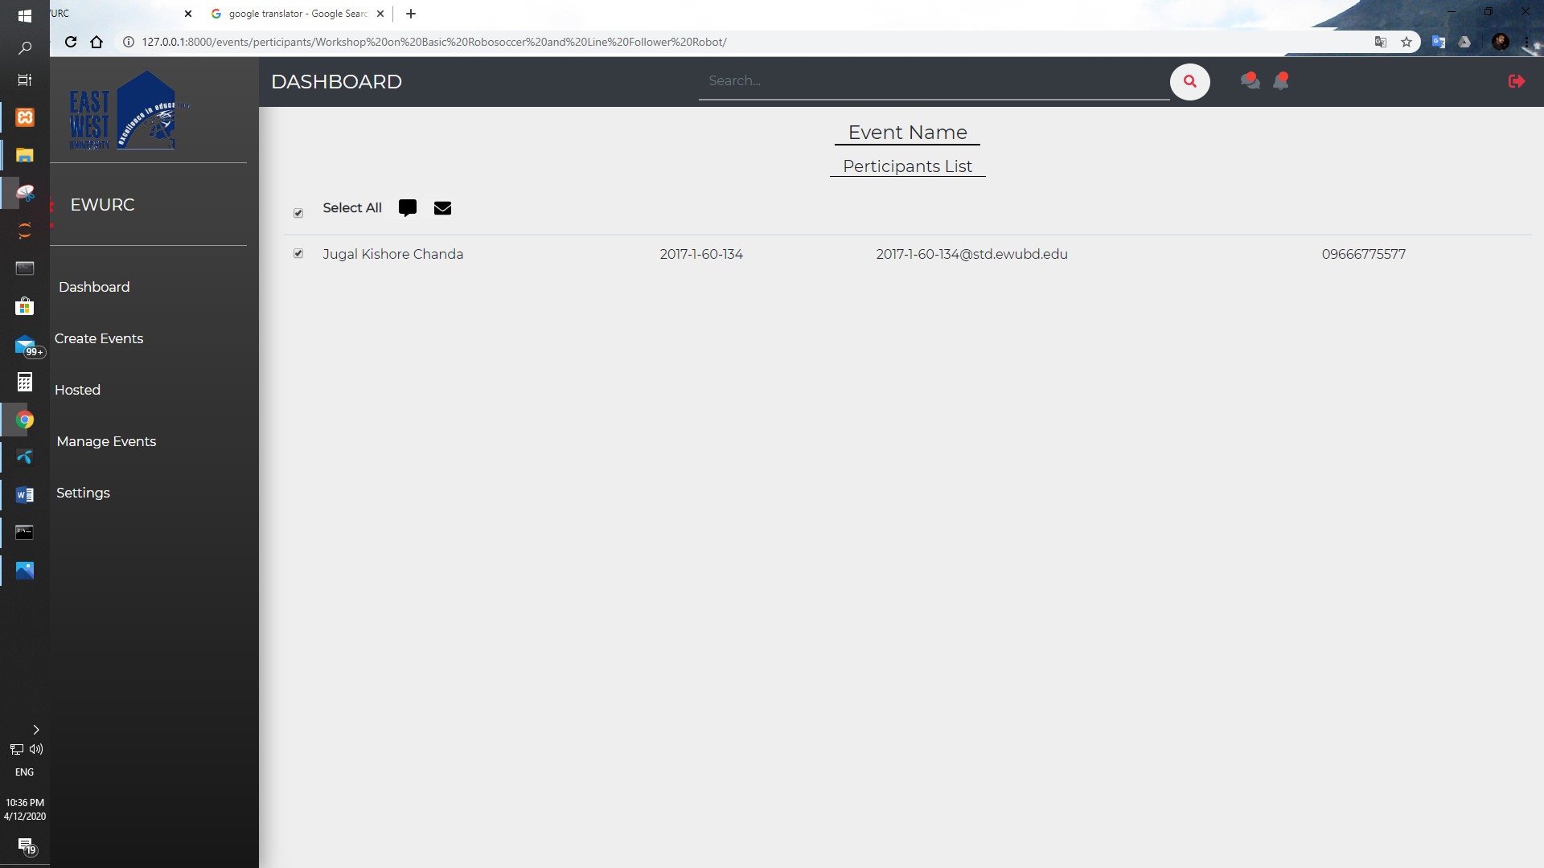

Then clicking email or envelope icon for sending email. Form option they can use participant name, participant student id etc. In email.

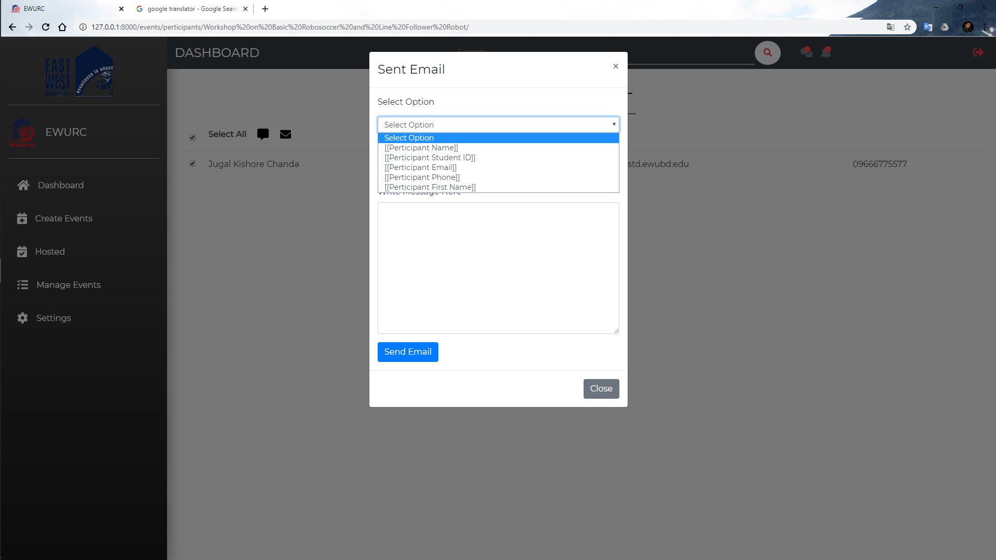

After giving all information EXECUTIVE can send email to the participants.

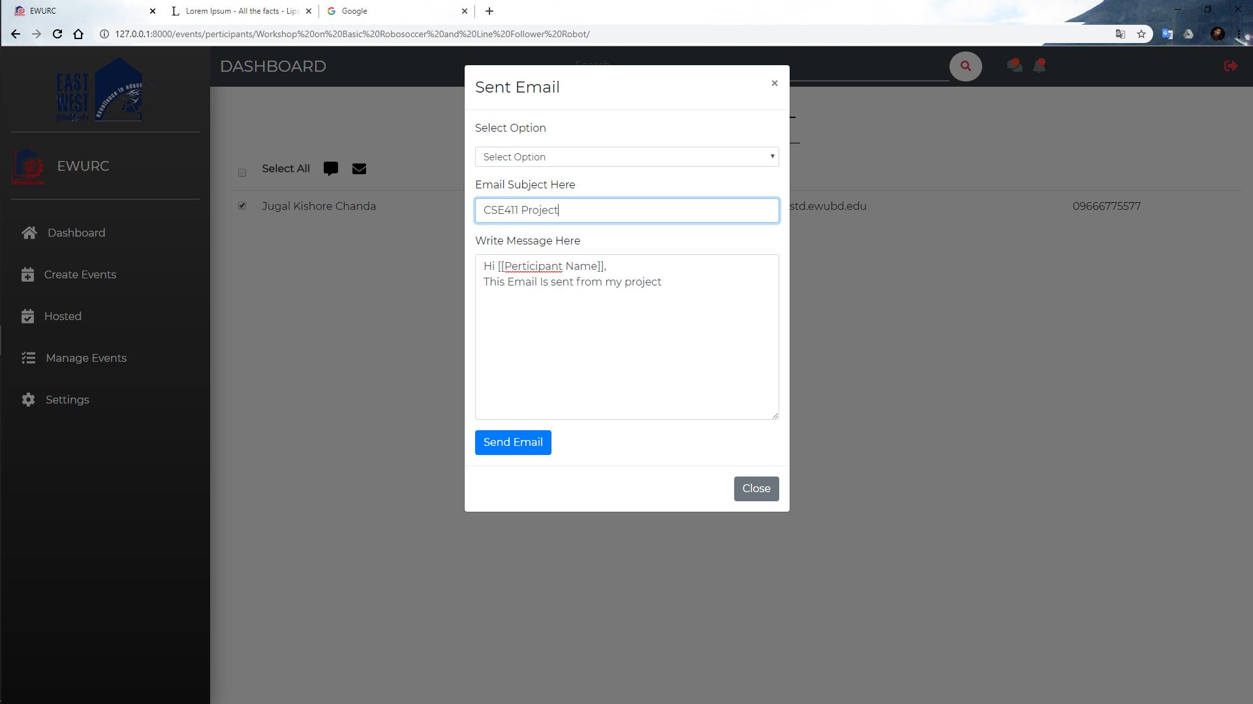

22) Before sending email clubs need to give their email address and email password. The email is sent from this email. It is set by going to settings option.

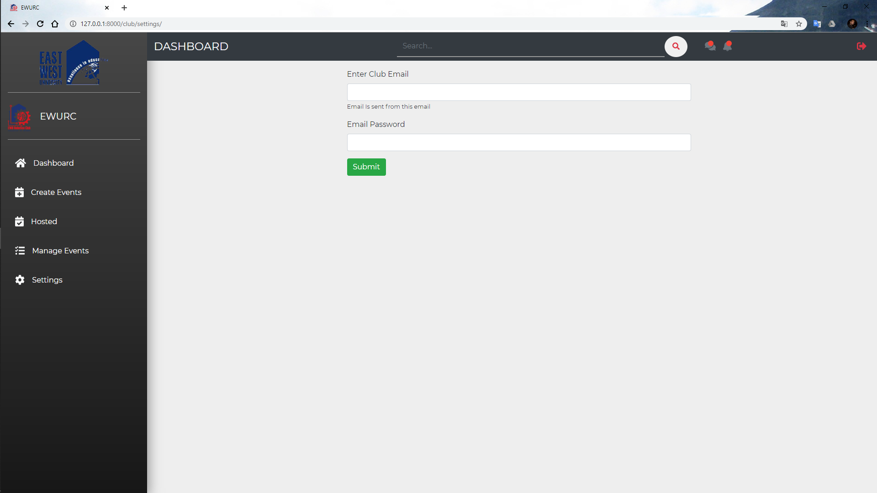

23) User can see all news. 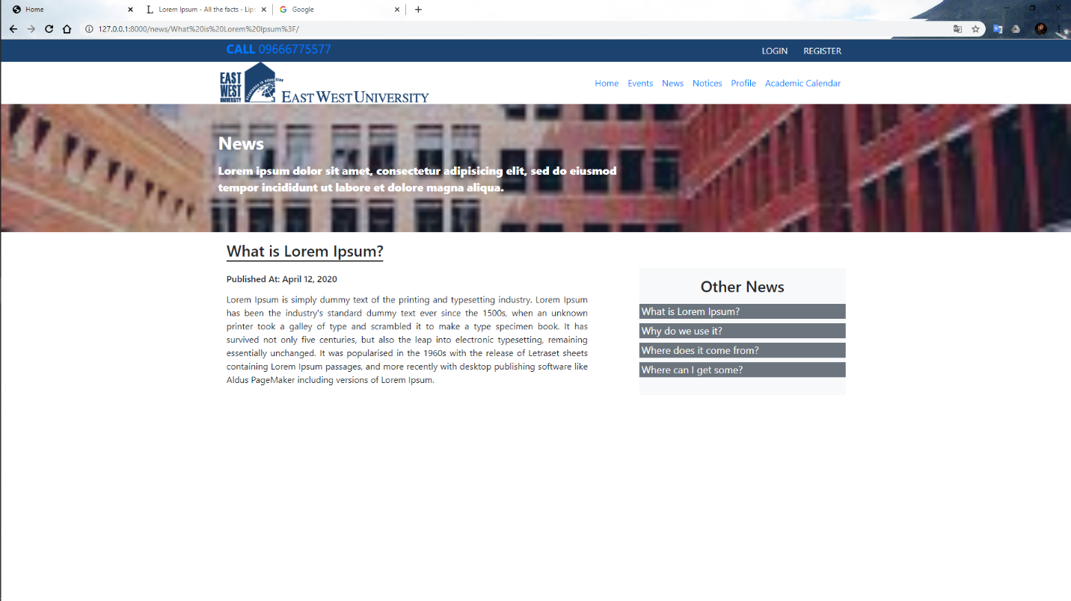

34)

24) User can see all notices.

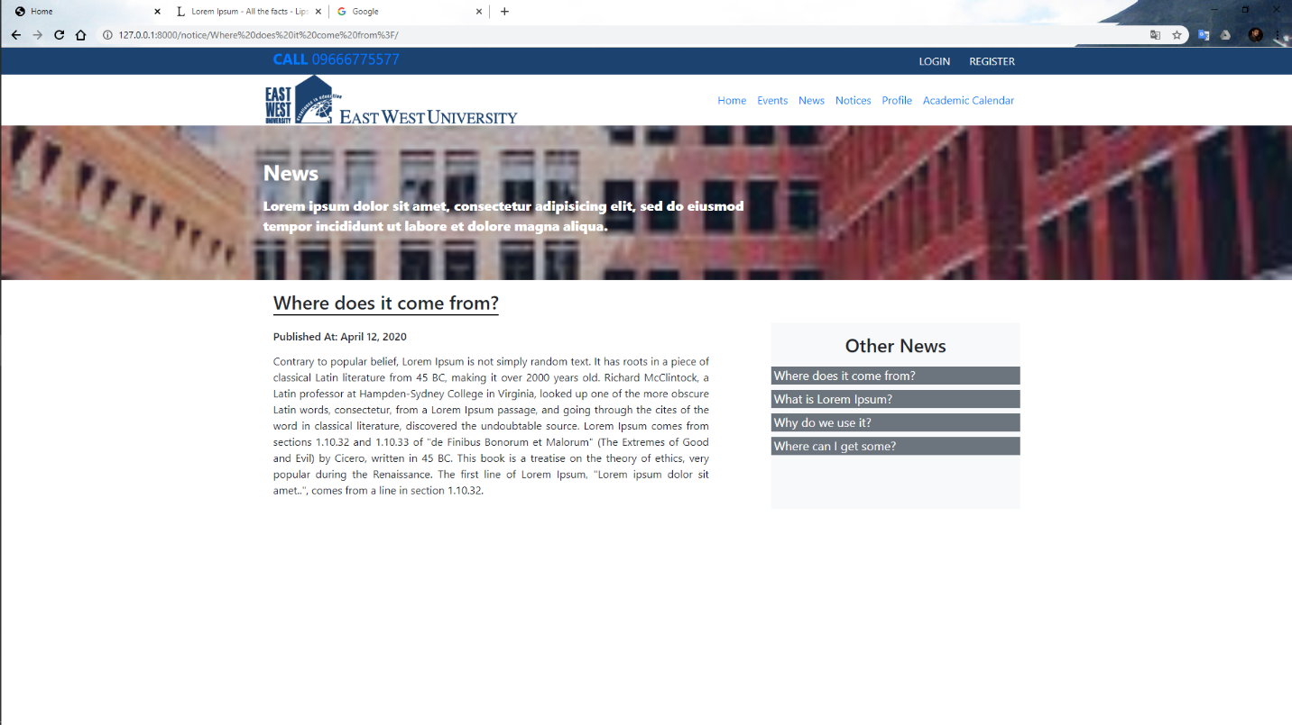

25) User can see academic calendar of this university.

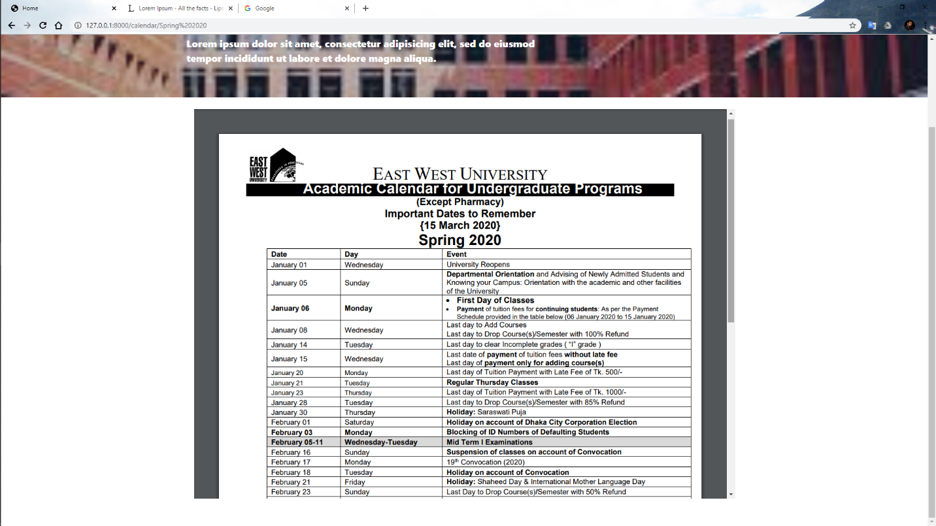

3.2 Hardware Interfaces

The minimum hardware requirements of that supported to install a web browser that can easily access internet. For locally run this need a Django install on this computer with MySql database.

3.3 Software Interfaces

To run this application, we need a browser. For locally run need Django, command line interface and MySQL database.

3.4 Communications Interface

For this application needs a good internet connection.

Appendix A: Analysis Models:

Use Case Diagram

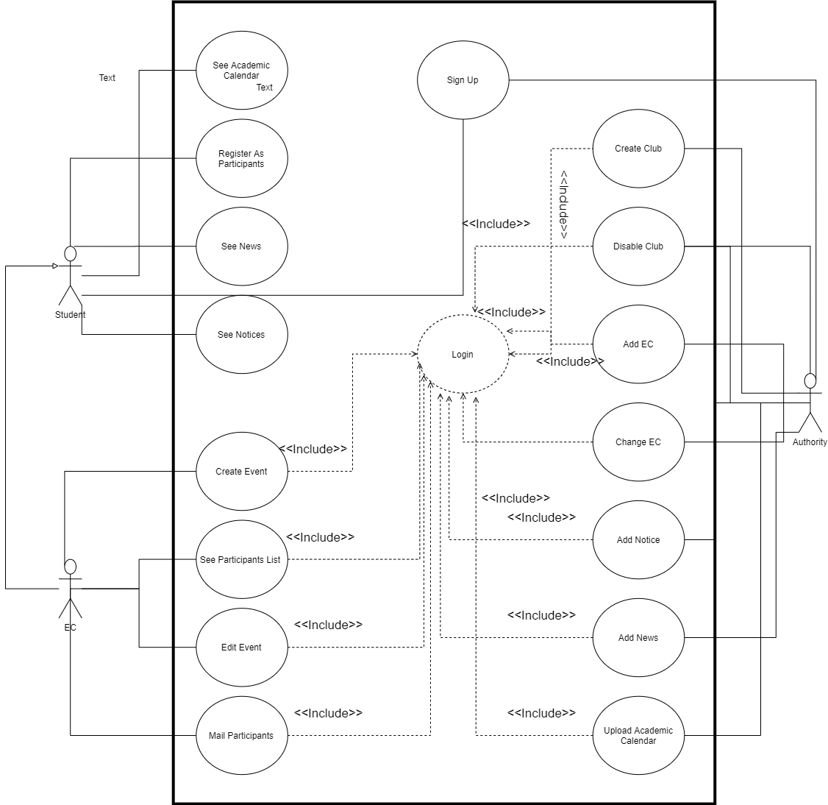

Class Diagrams

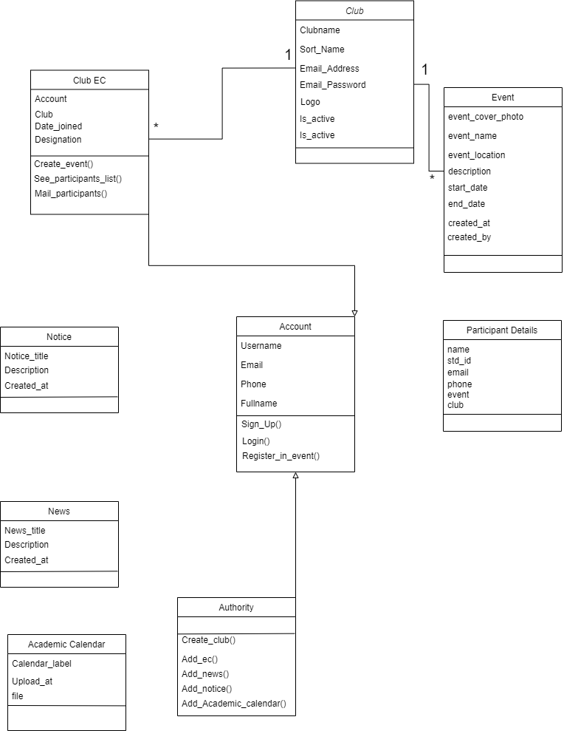

Sequence Diagram

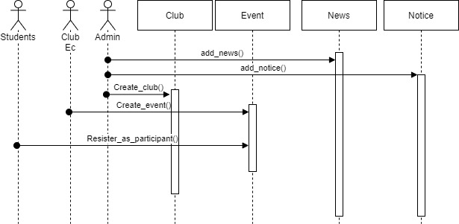

Activity Diagram:

